A Realtime Multiresolution Variable Window Stereovision Algorithm

Avishek Sen Gupta

Abstract

This paper describes a multiresolution algorithm for stereo vision. The spirit of the algorithm is based on the premise that for most purposes, depth maps of subpixel precision are not necessary. However, there will arise situations where calculations at high resolutions is required. This algorithm addresses this need effectively. The basic stereo algorithm based on area matching uses windows of fixed size which cause the so-called corona effect at discontinuities. This algorithm shows how to avoid that effect and simultaneously achieve multiresolution stereo vision in realtime.

Introduction

The problem of stereo vision is a much-studied one; several solutions have been proposed. Most of these solutions are concerned with the recovery of accurate depth maps with minimum number of mismatches. These algorithms are ranked with reference to some ground truth. However, they are not suited for realtime implementation, not at least without the use of specialised hardware. Moreover, it is to be noted that humans do not need an especially accurate depth map for reasonable stereo vision. That is, if the errors in recovering the depth map are kept below some maximum level, it is to be expected that most of the relevant informmation can still be recovered without significantly affecting plant performance.

This is the basic compromise that our algorithm makes. It forgoes complicated analyses which might determine and compensate for the effects of occlusion and other effects. However, the possible resulting loss in performance is made up to a very large extent by using the variable window approach. The resulting performance in terms of speed is very good, with errors kept within acceptable limits. Indeed, we intend to use this particular approach to build 3D models of the environment in realtime, which involves the fusion of multiple depth maps. Most errors in the individual depth maps are averaged out in the final 3D map. The description of this fusion algorithm is reserved for a future paper.

This paper is organised as follows. Section 1 describes the process of determining the variable window sizes. Section 2 then describes the basic matching algorithm and the associated disparity calculations. Section 3 shows results using this algorithm and discusses these results in brief. Finally, Section 4 describes our current test system and possible improvements to the algorithm.

Section 1

The first step of our algorithm is to determine the sizes of the windows to be correlated. Since speed is the primary objective, we use a technique called quadtree segmentation.

Quadtree decomposition is an analysis technique that involves subdividing an image into blocks that are more homogeneous than the image itself. This technique reveals information about the structure of the image. It is also useful as the first step in adaptive compression algorithms.

A typical quadtree decomposition function works by dividing a square image into four equal-sized square blocks, and then testing each block to see if it meets some criterion of homogeneity (e.g., if all of the pixels in the block are within a specific dynamic range). If a block meets the criterion, it is not divided any further. If it does not meet the criterion, it is subdivided again into four blocks, and the test criterion is applied to those blocks. This process is repeated iteratively until each block meets the criterion. The result may have blocks of several different sizes.

For example, suppose we want to perform quadtree decomposition on a 128-by-128 intensity image. The first step is to divide the image into four 64-by-64 blocks. We then apply the test criterion to each block; for example, the criterion might be

Max (block_intensity) – min (block_intensity) <= 0.2

If one of the blocks meets this criterion, it is not divided any further; it is 64-by-64 in the final decomposition. If a block does not meet the criterion, it is then divided into four 32-by-32 blocks, and the test is then applied to each of these blocks. The blocks that fail to meet the criterion are then divided into four 16-by-16 blocks, and so on, until all blocks ‘pass.’ Some of the blocks may be as small as 1-by-1, unless we specify otherwise.

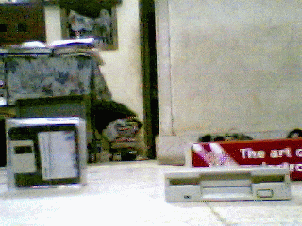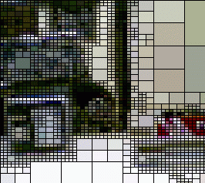

Section 2

This section describes the basic window cost function and shows the disparity calculations.

